**Edinburgh Fringe 2025 – Comedy**

**Kate Pinchuck: Don’t Panic!**

***Laughing Horse Free Festival - Brass Money: The Games Room (Venue 153) 31st July - -24th August, 12:45pm***

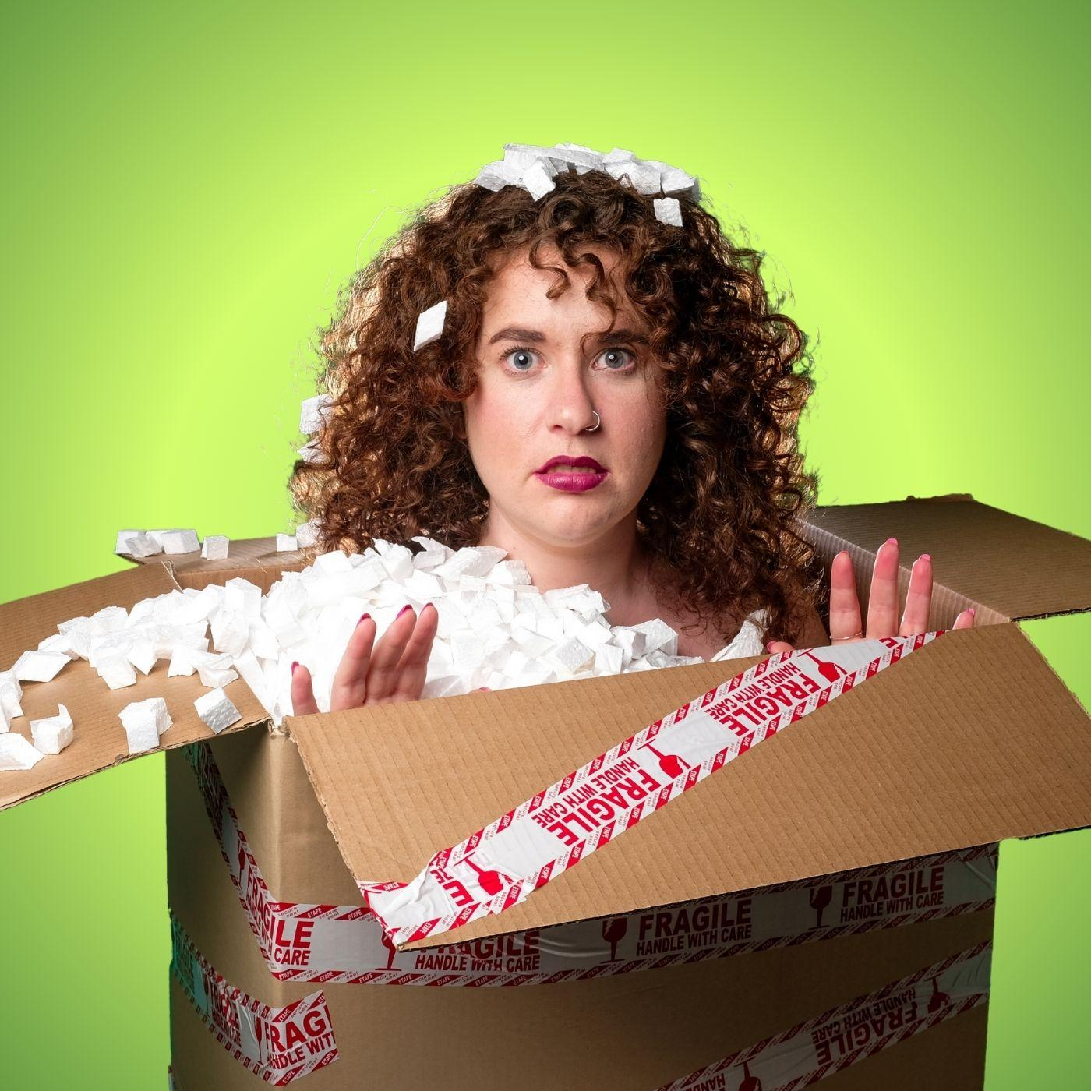

Sick of everyone banging on about their mental health issues? Just imagine how award-winning comedian Kate Pinchuck feels. She’s had a lifetime of therapy, medication, mental health walks AND two psychologist parents. Her whole identity was being unwell long before it was cool.

Now all of a sudden mental health has been destigmatised, and everyone is talking all about their boring diagnoses… in their Edinburgh Fringe shows.

With NHS waitlists growing and everyone desperate for some self-pathologising, it's Kate’s time to shine. This show isn’t just about her mental illness—it’s about yours.

Both a professional patient and daughter of two psychologists, Kate can remember a time when her parents were rolling their eyes at every second person’s ADHD diagnosis… in 2009. Enough problems - it’s time for solutions!

As the world’s foremost qualified unqualified pseudo-therapist comedian, Kate has realised that she is the perfect person to solve everyone else’s issues. So, step into her office for some comedic group therapy that promises to be as hilarious as it is unhelpful.

Can Kate cure a room of strangers in 60 minutes, or just drag you down with her? Only one way to find out!

**Don’t Panic!** debuted at the 2024 National Arts Festival in Makhanda (Africa’s biggest arts festival) where it won a prestigious Standard Bank Ovation award, and subsequently toured South Africa.

A multi-award-winning comedian and SAFTA-nominated actress (like a BAFTA, but less people care), Kate’s comedy has been praised as “smart, challenging and provocative” (Netwerk24). Kate’s work aims to push boundaries and taboos (“effortlessly turned life challenges that most people would find to be taboo into comedic gold” - Cue Media) and relentlessly pursue authenticity and vulnerability (“honest, unabashed, sharp, and engaging” - Netwerk24).

After a successful comedy and acting career in South Africa, **Don’t Panic!** will mark her Edinburgh Fringe debut and expand the reach of her “hilariously relatable” (Cue Media) comedic stylings and dubiously acceptable therapeutic practices.

**Contact:** Kate Pinchuck - [katepinchuck@gmail.com](mailto:katepinchuck@gmail.com) - 07577526306

**Instagram/Tiktok:** @katepinchuck

**Video link:**

<https://www.youtube.com/watch?v=G9740UQw5bQ&t=4s&ab_channel=KatePinchuck>

**Venue:** Free Festival Brass Monkey: The Games Room (Venue 153)

**Dates & time:** 31st July -24th August, 12:45 - 13:45 (60 minutes)

**Age:** 18+ (venue guideline)

**Tickets:** Pay what you can

**Edfringe Link:** <https://www.edfringe.com/tickets/whats-on/don-t-panic>

**FREE TO USE PRESS IMAGES:** <https://drive.google.com/drive/folders/1Zrigr3YCYJgNfqVXOg6a7-NbexcyATEm?usp=drive_link>