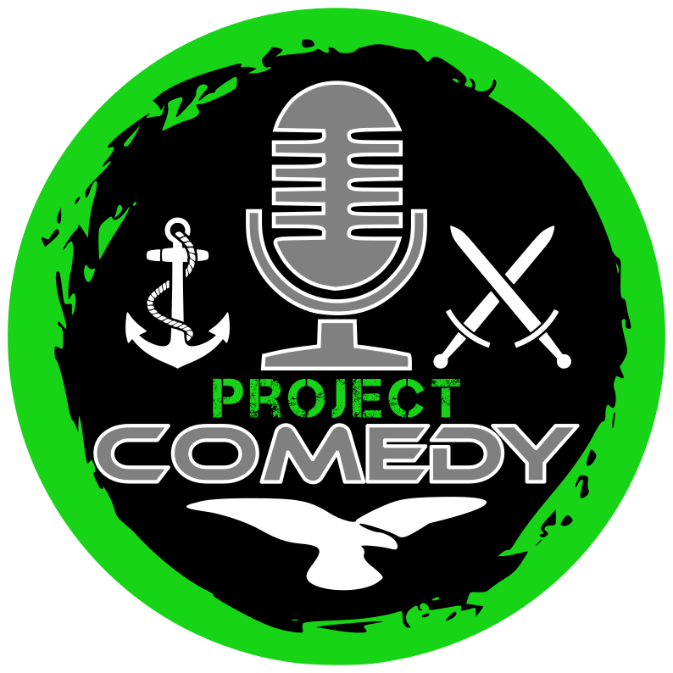 | info@projectcomedy.co.uk  www.projectcomedy.co.uk  Lead Ambassador - Jay Saunders  07586 429355  Ambassador - Nick Cheng  07536 136490  FOR IMMEDIATE RELEASE

UK Military Veterans Find Their Voice Through Laughter as Project Comedy Makes Edinburgh Fringe Debut

From 31 July to 24 August, a group of UK military veterans will take to the stage at the Edinburgh Festival Fringe, not with tales of combat, but with punchlines and personal stories, as Project COMEDY makes its highly anticipated debut with two unique comedy shows.
Founded during the Covid national lockdowns as a well-being initiative by parent charity Project RECCE, Project COMEDY has evolved into a transformative platform. It offers veterans and serving personnel the opportunity to engage in stand-up comedy, aiding in their transition, recovery, and overall well-being.
The program emphasizes the unique experiences of military life, encouraging participants to share their stories and find humor even in the darkest situations. As the organization states, ‘They find the way to make light of horrible situations, conditions and injuries – they even find ways for people to learn about things they may have been uncomfortable to ask of a veteran and gain greater understanding.’
One of the standout voices is Nick Cheng, a Project Comedy Ambassador, who encapsulates the program’s ethos with his mantra: “Better to tell a gag than be Mad, Sad & Bad…” ￼
Jamie Johnson, another ambassador, shares the profound impact the program has had on his life: ￼“Since starting my comedy journey I’ve learnt ways to become comfortable being uncomfortable. Hence it’s enabled me to build my self-confidence and engage with the civilian world in a positive, constructive and humorous manner.”
As Jay Saunders, who goes on stage with his PTSD assistance dog Hawke stated: “To say Project COMEDY has saved my life would be an understatement. I’ve now got joy and laughter in my life and when I tried to end mine in a moment of darkness, it was my fellow veterans doing comedy that called 999 and got me the help I needed.”
The performances promise a blend of raw honesty and humor, offering audiences a unique glimpse into the lives of those who’ve served. As the organization highlights, ‘Every member of the UK Armed Forces has an individual story to tell… They get to use all of their history and experience to develop material that most would never even consider.’
Project Comedy’s Edinburgh Fringe debut runs every day of the Festival Fringe. 12:30 with its competition show ‘Should Have Tried Harder at School: Veterans v Civilian’” at the Garden Room, Bar 50 and at 5:45 at Kick Ass with their feature show ‘Gags Army’. Each performance will feature different veterans from across the UK, sharing their stories one laugh at a time.
Both shows are presented as Pay What You Can performances, but seats can be reserved for reviewers by emailing Project COMEDY (email address at the top of this media release).

General public tickets can be purchased at:
Should Have Tried Harder at School – Veterans v Civilians
https://www.edfringe.com/tickets/whats-on/should-have-tried-harder-at-school-veterans-v-civilians
Gags Army
https://www.edfringe.com/tickets/whats-on/gags-army
Help show our veterans that their voices — and their laughter — still matter.

