presents

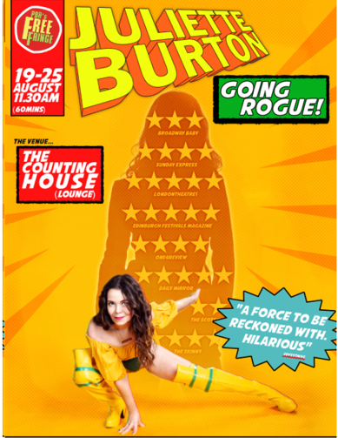
JULIETTE BURTON: GOING ROGUE

AS PART OF THE EDINBURGH FESTIVAL FRINGE 2024

Venue: Laughing Horse Free Fringe – Counting House (Venue 170)
Dates: 19th August to 25th August
Time: 11.45am (12.45pm)
Note: Comedy storytelling, Work in progress, LGBTQAI+

“INSIGHTFUL AND FUNNY” British Comedy Guide
“LOVABLE HUMOUR” The Skinny
“huge talent.” ★★★★★ Daily Mirror
“WORLD CLASS COMEDY WITH A BIG HEART… Incredible human warmth” Australian Stage
Geek is the new sexy. As a young nerd Juliette loved dressing up. She also loved comic book characters, particularly Rogue from The X-Men - funny, dark past, great costume. Skip to the 2020s and Juliette is ”award-winning comedian and activist” masked in glitter, armoured in sequins. But no costume can arm you for life’s challenges.
“Educational and hilarious.” ★★★★★Edinburgh Festivals Magazine
“forms a strong rapport with everyone. this is a safe space” Broadway Baby
Join her on a journey from cosplay to confidence. From Star Wars to stardom, from despair to DC, from Marvel to marvellous and What If to What Next? Dressing up can reveal more than you expect. Where does your power lie?
Covering topics raging from breakups to breakdowns, ADHD to misogyny, feminist rage to LGBTQAI awakenings, feeling lost to found family – this mutant invites her tribe and her XMen to join her for this work in progress fiasco full of love.
“INTELLIGENT, EMOTIONAL, LIBERATING.” ★★★★★Voice Magazine
Juliette Burton is an award-winning performer, writer, presenter, and broadcast journalist. She has previously performed six critically acclaimed total sell-out solo seasons (When I Grow Up, Look At Me, Decision Time, Butterfly Effect, Defined and No Brainer) at the Edinburgh Festival Fringe with total sold out shows five years (2015, 2016, 2017, 2018, 2023).
She has performed at Festivals around the world including Leicester Comedy Festival, Adelaide Fringe, Melbourne International Comedy Festival and New Zealand International Comedy Festival. In 2015 Juliette won the Argus Angel Award at Brighton Fringe for Look At Me and Voice Magazine Pick of the Fringe in 2017 for Butterfly Effect.
As a writer, Juliette has contributed to The Independent, i Newspaper, Cosmopolitan and BBC News. She is an ambassador for mental health charity ReThink Mental Illness, and supporter of Mind, B-eat and writes for MQ Mental Health Research.
Juliette’s stand up show, Juliette Burton: Hopepunk, will premiere at this year’s Fringe on 31st July to 16th August at 7.40pm in Gilded Balloon’s Patter Hoose. Her chat show ‘Juliette Burton’s Talking Crazy’ will be at Gilded Balloon’s Patter Hoose on 12th and 13th August at 5.30pm discussing the politics of madness with special guests. www.julietteburton.co.uk
JulietteBurtonWriterPerformer | @julietteburton | jjuliette_burton
For further information please contact: Juliette Burton on 07775 691774 or juliette@julietteburton.co.uk

