PRESS RELEASE 12/6/24

Pam Ford

aka SPAM FORD
Genre: True Life, Comedy, Stand-up
August 1st to 24th 5.50pm Edinburgh, City Cafe
Author and Performer: Pam Ford
Director: Roland Saunders
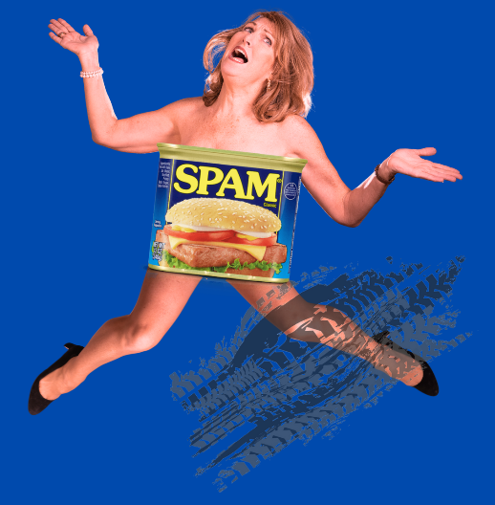
Born in Birmingham England and raised in Australia, Pam is a proud Brit (been back now 33 years) but just cannot hide her broad Aussie accent and ballsy optimistic outlook on life. Surviving school bullies, 70’s food, fashion and pop idols. Trying so hard to fit in, a few falls along the way. By the end you’ll “fall in love with her” No Spam is served here today unfortunately. Lovely intimate room which is air-conditioned (thank heavens for other menopausal baby boomers)
Directed by Roland Saunders who says “this show has lots of thrills, retro stuff, surprises it’s a full on hour of fun”
Adelaide audience review March 2024 “Pam Ford’s show was an excellent entertaining story of a life living with each foot in Australian and English culture, many will relate to and find hilarious and emotional. Her comedic style is a perfect blend of Dave Allen and your favourite aunty whos always up for a gossip and a laugh.”
Pam Ford a regular feature at The Edinburgh Festival this is her 8th one-woman solo show. True-life Comedy. Being constantly asked ‘where are you ‘really from?’ Gets a first hand feeling of what immigrants to our shores het all of the time! Pam is an ex pub landlady and now stand up comedian and entertainer. Engaging Enthusiastic thoroughly entertaining.
**** SCOTSMAN for previous 2022/23 show “Don’t You DARE put me in a care-home”
For tickets or more information and interview requests contact
Roland Saunders rolandcat@Gmail.com 07766023450

