**MEDIA RELEASE**

**Can You Survive as Ruler of a Kingdom?**

A new gameshow that brings comedians & audiences to the throne room,

or to the guillotine.

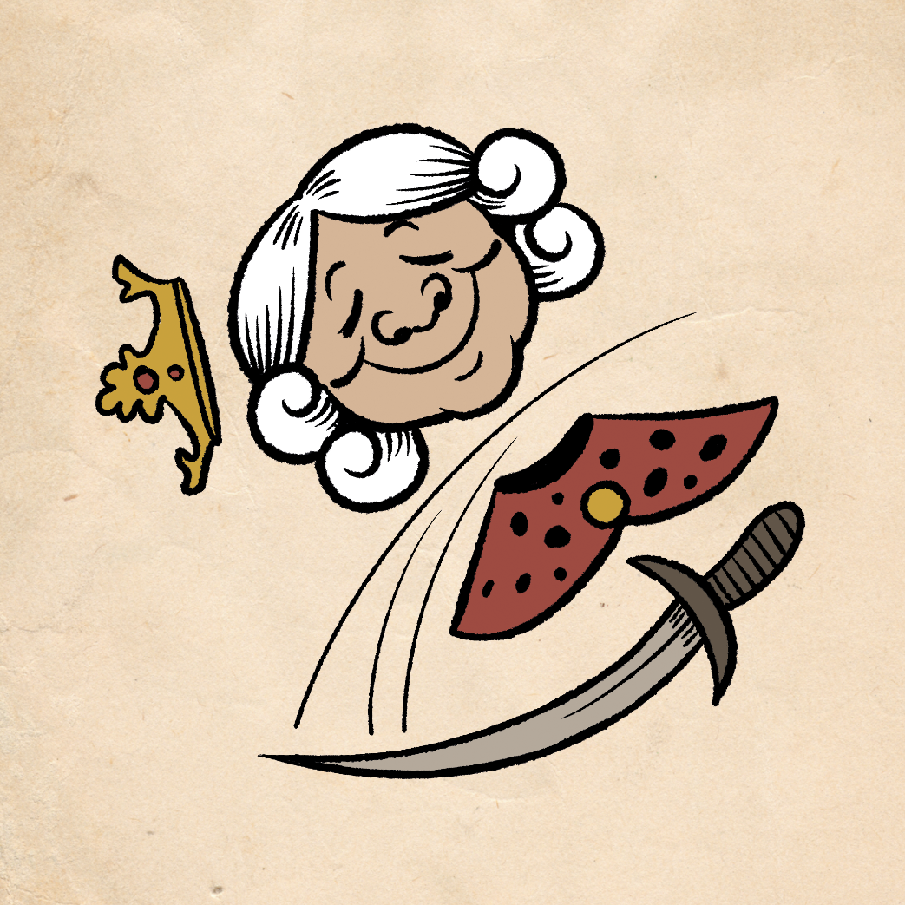

**Off With Your Head!**

**14 June 2024, London** – A brand new live gameshow, **Off With Your Head,** makes its official debut at this year’s Edinburgh Festival Fringe. Developed & Hosted by comedian Sam See and game designer Stephen Case, the show invites audiences and two comedians to enter a fictional medieval kingdom. Cursed to have rulers that can never stay king, queen, or ruler for longer than a month, they are then tasked, one by one, to rule over the kingdom and try to survive past the twelve months and break the curse on their lands. The show involves crowd interaction and participation, as audience members may themselves be part of the game as helpers or obstacles. Audience member will also play the game as the monarch in charge, alongside the two comedians, making decisions and rolling dice to determine their fate.

The show uses multimedia, props and costumes, and was inspired by the video game *Reigns*, as well as the live show *The Dark Room* by Australian John Robertson.

**Off With Your Head** will be performed daily (Sans Tuesdays) at 20:30, from August 1st (Thursday) till August 25th (Sunday) at 32 Below, in the Main Cellar. The show is part of the Laughing Horse’s Free Edinburgh Fringe Festival.

**Off With Your Head!**

**Dates: 1st-25th August 2023 (No Tuesdays), 8:30pm  
Location:** [**32 Below**](https://www.google.com/maps/place/32+Below/@55.944554,-3.1850935,15z/data=!4m2!3m1!1s0x0:0x7a2c1445cf1ddf6d?sa=X&ved=1t:2428&ictx=111)**, 32b W Nicolson St, Newington, Edinburgh EH8 9DD, United Kingdom**

**Duration: 55 mins**

**Rating: 18+ (Restriction due to venue laws)  
Show Listing on EdFringe.com:** [**https://tickets.edfringe.com/whats-on/off-with-your-head**](https://tickets.edfringe.com/whats-on/off-with-your-head)

For more information, or to arrange for media enquiries, contact:

Sam See | [comedy@mrsamsee.com](mailto:comedy@mrsamsee.com) | +44 07449 299708