Barnstormers Comedy Presents:

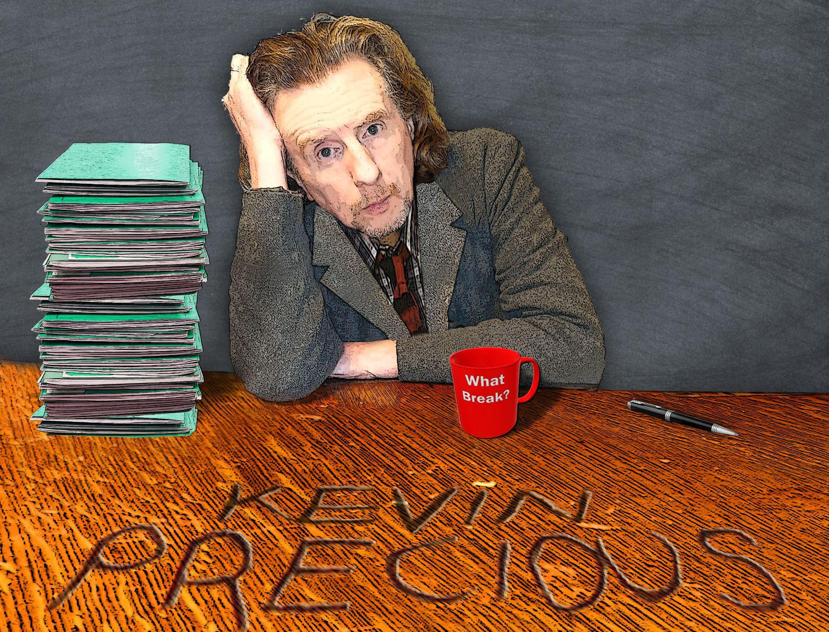

Kevin Precious: The Reluctant Teacher
Kevin Precious used to be a teacher. He enjoyed the teaching part; it was the stuff that goes with it that was a drag. So he left.

Edinburgh Fringe, 16:45, 3rd-27th August 2023
Venue 170, Laughing Horse @ The Counting House, 38 West Nicolson Street, EH8 9DD
Part of the Free Fringe

'Kevin's stage charisma and poise set him head and shoulders above the previous acts' (Times).

Determined to get a “Grown Up Career” after years spent as a musician, Kevin trained as a Religious Studies Teacher, despite being an affirmed sceptic and non-believer. Whilst wrangling with disinterested kids in various Secondary Schools in Sussex during the day, Kevin increasingly pursued the business of stand-up comedy at night… inevitably something had to give. The show is a funny overview of the pitfalls and pratfalls that go with Kevin’s former profession of teaching; with a bit of pedagogical stuff (ooh-er) thrown in for good measure.

'Instantly recognisable stage presence and boundless wit' (Leicester Mercury).

Biography:
Kevin Precious has been a full time stand-up comedian since the mid-noughties. He has performed variously at most of the top clubs in the country including full weekends for the Glee, the Stand, the Frog and Bucket, ROFL Comedy and the Comedy Lounge; as well as appearing at renowned London gigs such as the Banana Cabaret, the Covent Garden Comedy Club and Downstairs at the Kings Head. More recently he has worked for Comedy Store on the Road. His comedy travels have also taken him to further flung destinations including Amsterdam, Maastricht, Budapest, Bucharest, Dublin and Ibiza.

Images
https://www.dropbox.com/home/Kevin%20Precious%20The%20Reluctant%20Teacher

Social media links:
https://www.facebook.com/kevinpreciouscomedy/
https://www.instagram.com/kevinprecious5/
https://twitter.com/kevinprecious

Website link:
https://kevinprecious.co.uk/
Previews:
Mon 29/05 - Thu 01/06 Brighton Fringe
Fri 09/06 Barton-upon-Humber
Fri 16/06 Winchester
Sun 18/06 Horsham (filming)
Sat 08/07 Leighton Buzzard
Thu 13/07 Hull Truck
Sat 29/07 Goole

Press night in Edinburgh 3rd August 2023

Media Contact:
Kaye Freeman at Andromeda Talent kaye@andromedatalent.com / 07881 825287

