EDINBURGH FRINGE 2023

COMEDY

Fringe Management/Free Festival
Present
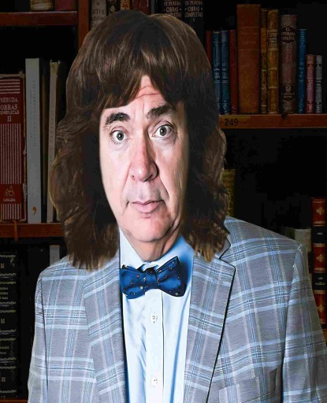

Edinburgh Fringe 2023
COMEDY
SHAGADELIC: THE ORIGINS OF SLANG WORDS FOR DOING IT

August 17-27

15.45 (60 mins)

HANOVER TAP – WEE TAP
www.freefestival.co.uk

Tickets: PWYC

SHAGADELIC: THE ORIGINS OF SLANG WORDS FOR DOING IT

Written & Performed by Michael Blaha

August 17th-27th 15.45 hrs

HANOVER TAP – WEE TAP (venue 259)

Sell-out hit of the Hollywood Fringe Festival!
Fresh off his critically acclaimed 2022 Edinburgh Fringe show, ‘Spanking the Monkey: The Etymology of Onanistic Euphemisms’ (★★★★ - The Scotsman) Professor Richard Fondler returns to the hallowed halls of the Fringe to deliver his lecture on the origins of euphemisms for making love around the world. Whether you're shagging in the UK, doing somersaults in France, kicking up the dust in Spain, or boom-booming in Thailand, you will be entertained and enlightened by Professor Fondler's survey of international slang words for making the beast with two backs.
Top Ten/Recommended - stageraw.com
Gold Medal ('A wonderful blending of exceptional erudition and downright goofiness') – thetvolution.com
'Absolutely hilarious, brilliantly clever' – nohoartsdistrict.com
MICHAEL BLAHA (Writer/Performer) – In addition to 'Spanking the Monkey: The Etymology of Onanistic Euphemisms'. Mike has written and performed in a number of movies and plays. He co-wrote the comedies 'Murder, Inc.' (optioned by TriStar Pictures) and 'Wingin’ It' and wrote the horror comedy script 'Maliboo!' which is in development with Morafilms. Mike has acted in the independent films 'First and Last,' 'We Married Margo' and 'According to Occam’s Razor' and his theatre credits include 'The Canterbury Tales,' 'The American Dream,' 'Three,' 'The Donkey Show' and 'Zsa Zsa and Me.' Mike is also well known in the international theatre community as a prolific producer of Hollywood, New York, and Edinburgh Fringe comedies, plays, and musicals, having produced over 100 Fringe shows since 2001. Mike is an entertainment lawyer, arbitrator and law professor in his spare time.
FRINGE MANAGEMENT, LLC (Producer) has produced over 100 plays around the world, including over 90 shows at the Edinburgh Festival Fringe (winning them the coveted Spirit of the Fringe Award), including the Fringe First winner 'runt,' (Sony Radio Academy Award for BBC World Service production); 'This is So Not About the Simpsons' (starring Harry Shearer of 'This is Spinal Tap' and 'The Simpsons' and several productions featuring the international comedy sensation The Pajama Men (Perrier Best Newcomer Nominee, Times Dubble Act award, Melbourne and Sydney Comedy Festival Winners, Soho Theatre London Box Office record). Its other producing credits include 'Latina Christmas Special' and 'Bard Overboard' (Soho Playhouse Off-Broadway), the Hollywood Fringe Festival productions of 'Richard Parker' (Best International Production), 'Bumpersticker' (Best Musical Nominee) and 'Pick of the Fringe”' (two-time Best Cabaret nominee) as well as 'Bukowsical' (Best Musical Winner) at the New York International Fringe Festival.
CONTACT: mike@fringemanagement.com

