MEDIA RELEASE

Gay Comedian Asked by Government
to Teach Love & Sex During Pandemic
Sex Education Comedy Show returns to the Fringe

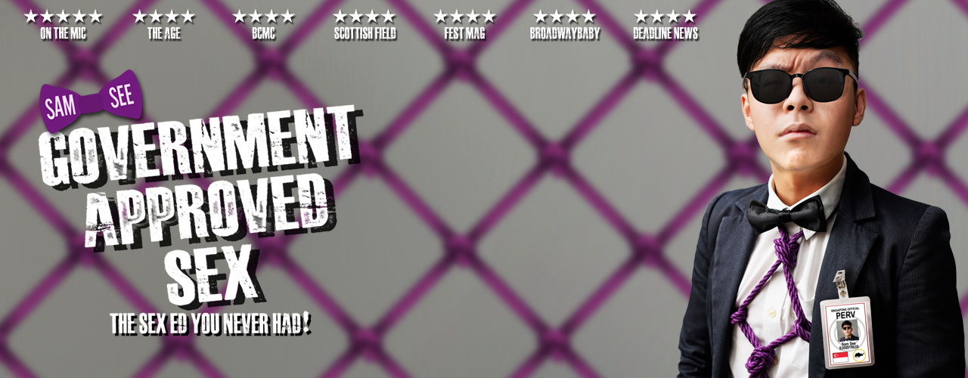

Sam See: Government Approved Sex

14 June 2023, Singapore – After being listed on Fest Mag’s “The Best of the Edinburgh Festivals 2022” and receiving ★★★★ from The Age during the Melbourne International Comedy Festival, Sam See is returning to the Edinburgh Festival Fringe with his show ‘Government Approved Sex’.

During the pandemic, Sam See was asked by the Singapore government to run a series of educational panels in the National Library about love and sex. Government Approved Sex returns to the Fringe after a critically acclaimed run in 2022, a stand-up comedy show about relationships, BDSM and, of course, scientific facts. The show covers love languages, a virginity guessing game, and a love story at the heart of it all.

The show is part of the Laughing Horse’s Free Edinburgh Fringe Festival, and tickets are under their ‘Free & Unticketed’ system. This year, the show is teaming up with Waverly Care, Scotland’s leading HIV and hepatitis C charity, with proceeds from the show going to their cause.

Dates: 3-27 August 2023 (No Tuesdays, 8th/15th/22nd), 7:15pm
Location: The Counting House, 34 W Nicolson St, Newington, Edinburgh EH8 9DD, United Kingdom
Duration: 55 mins
Rating: 16+
Show Listing on EdFringe.com: https://tickets.edfringe.com/whats-on/sam-see-government-approved-sex

This will be See’s third Fringe, having performed an hour show there in 2019 and 2022. His previous shows have been awarded ★★★★ by BroadwayBaby, Fest Mag and Scottish Field. He has also played the Melbourne International Comedy Festival and has been shortlisted for the Just for Laughs Comedy Festival in Montreal.

For more information, or to arrange for interviews/reviews, contact:
Sam See | comedy@mrsamsee.com

Press/Media Assets available here. Thank you!

Warmest regards,
Sam See

Social Media:

