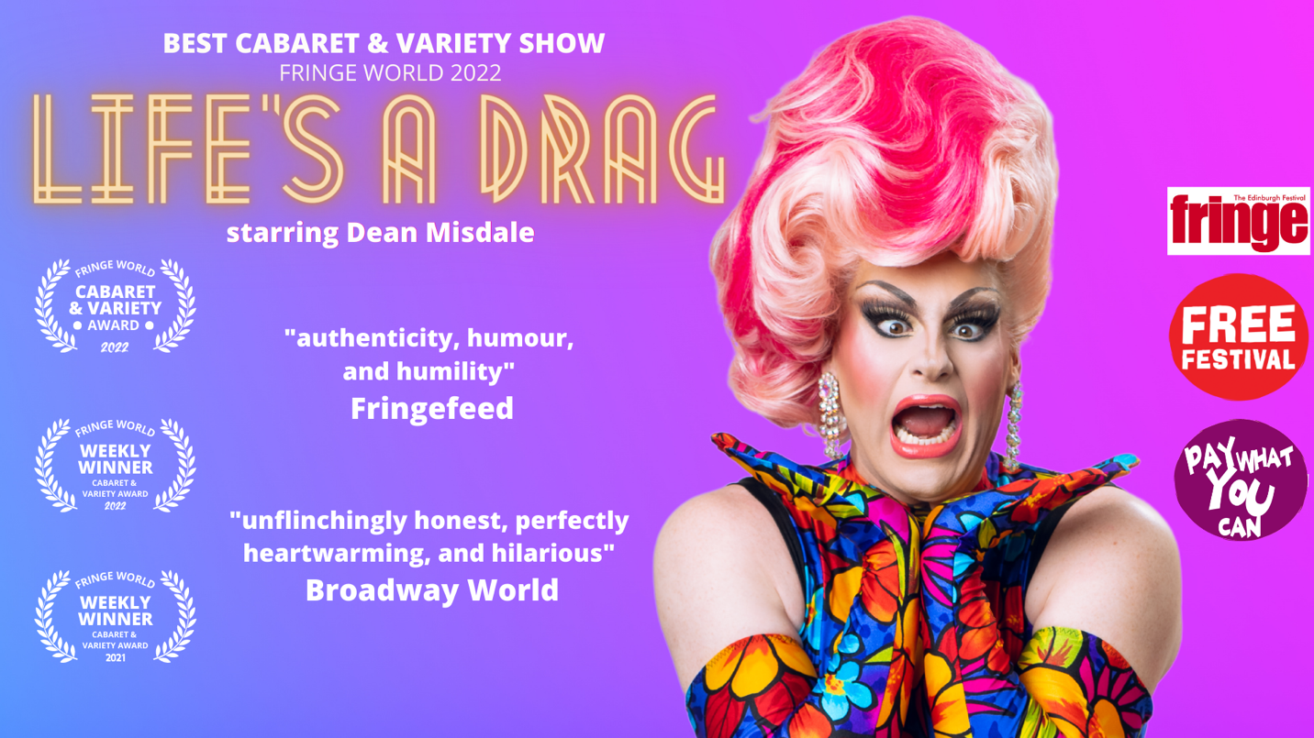

LIFE’S A DRAG

One of Australia’s brightest drag stars is coming to light up Edinburgh Fringe

After slaying local audiences and picking up the Best Cabaret & Variety Show 2022 award at Perth’s Fringe World Festival - the world’s third largest fringe festival - vocal powerhouse Dean Misdale has set their sights on the big one.

A quintuple threat of singing, dancing, acting, DJing and drag, Dean Misdale is ready to share their story with the world in Life’s A Drag, a side-splitting cabaret that delves into the highs and lows of life in wigs, and navigating the world of queerness and gender.

From intimate tales of coming out to hilarious misadventures in dating, nothing is off-limits in Dean’s autobiographical extravaganza.

A multi-award-winning artist, Misdale has stormed stages across Australia. From their home bar at the Southern Hemisphere’s oldest LGBTQIA+ nightclub Connections, to our most prestigious theatres and biggest arenas - including sharing the main stage with the one and only Adele (while dressed as Adele!).

Taking to the stage as Adele’s doppelganger is not the only time Misdale has made the history books. Dean wowed audiences as the first drag performer in Australia to take on the role of Killer Queer in a production of We Will Rock You The Musical, garnering rave reviews and acclaim for the role. Dean also entertained thousands as Miss Understanding in Priscilla Queen of the Desert - The Musical, in Perth’s massive Crown Theatre.

LIFE’S A DRAG will be at The Pear Tree at Edinburgh Fringe from August 4 - 28.

For more information, head to deanmisdale.com

Dean (they/them) is available for interviews. Please contact bookings@proudentertainmentgroup.com for details.

FACEBOOK | INSTAGRAM | PHOTOS | REVIEW | AUDIENCE REACTIONS

ACCOLADES
"unflinchingly honest, perfectly heartwarming, and hilarious" Broadway World, 2022
"authenticity, humour, and humility" Fringefeed, 2021

