EDINBURGH FRINGE 2022: COMEDY

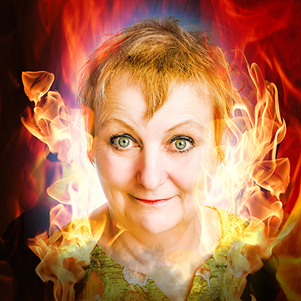

Charmian Hughes: She! The Immortal Horror Queen’s Guide To Life

What does a Bond Girl, a Hammer Horror villainess and a Colossal Squid have in common? They all mentored Charmian in the game of life.

The Counting House (Attic), Edinburgh
4-28 August @ 6pm

In 1965, as Feminism ‘s second wave lapped at the shores of a fading British Empire, eight-year-old Charmian Hughes (British Comedian of The Year finalist) saw the iconic Hammer Horror film ‘She’, starring Bond Girl Ursula Andress.

The story of a mysterious and murderous queen who has endless beauty, power and immortality but wastes them on some English bloke who could be the reincarnation of her long-lost lover, filled young Charmian with horror. Is that what being any kind of successful woman looked like?

But by the time Charmian was 17, idolising her older glamorous dollybird sister, and desperate for a boyfriend, she was trying those deadly womanly wiles herself. But what makes you a great girlfriend in 1000 years BC makes you a terrible girlfriend in 1973.

Now, all these years later, for Charmian, happily married and a comedian, running into that old boyfriend again unleashes old obsessions, resentments, and jealousies.

As we get older and our future contracts, does the immensity of the past hold answers?
Can an encounter with a Colossal Squid save Charmian from herself?

‘I LOVE Charmian Hughes.’
Bridget Christie

‘Pick of my fringe.’
Arthur Smith

Charmian Hughes has been performing stand-up comedy for over three decades, in venues as varied as the Comedy Store, the Glastonbury Festival, the Houses of Parliament and HMP Wormwood Scrubs.

She has taken her comedy to the Dublin Comedy Festival, Scilly Laughs Festival, Melbourne Comedy Festival, and the New Zealand Fringe- where she got stuck in their lockdown in 2020!

Charmian also runs comedy workshops, and this year assisted comedian Angie Belcher in her daring new NHS backed Comedy On Referral project, where comedy is used as therapy. As his former comedy teacher, Charmian also appeared in Micky Flanagan’s TV show Peeping Behind The Curtain.

Charmian has also acted in plays at the Edinburgh Fringe for Comedians Theatre Company and Kazzum Theatre.

Charmian was a finalist in British Comedian of The Year, nominated twice for Buxton Fringe Festival’s Best Comedy Show - including last year with this show. This is her tenth solo show at the Edinburgh Fringe and is directed by Amanda Baker.

‘Irresistible combination of delightful lady comic and legendary, merciless temptress tops my list for Fringe.'
Kate Copstick, Scotsman

'Best gags of night.'
Independent

'Charming ribaldry.'
Guardian

'Mad Aunt on Acid.'
New Zealand Herald

'Funny and Profound.'
New Zealand 'NZ Stuff'

‘A class above other stand ups not to be missed.’
NZ Theatreview

‘A ferocious superpower lights up show.’
Scotsman

‘A joy.’
Funny Women

‘Clown Princess lights up show.’
Bridport News

Preview dates:

June 2nd 7.30pm Brighton Fringe at Secret Comedy Club Artista Cafe Hove
June 6th Downstairs at The Kings Head Crouch End
June 12th 6pm The Poodle Club Sydenham
July 10th Morecambe Fringe 8.15pm
July 21st at 8.30pm Buxton Fringe at The Old Clubhouse
July 22nd 10.30pm Buxton Fringe at The Old Clubhouse
Aug 5th 6pm The Counting House Attic, Edinburgh

Listing:

Title: Charmian Hughes: She! Immortal Horror Queen’s Guide To Life
Venue: Laughing Horse @ The Counting House (Attic).
Link: www.charmianhughes.co.uk
Fringe Venue Number: 170
Dates: 4 – 28th Aug
Press from: 4 August
Time: 6pm
Age: 16+
Duration: 60 minutes
Entry: £5/£7.50 £10 £12 PWYW

Media contact: Charmian Hughes charmhug@gmail.com 07876033517

Photo link: https://charmianhughes.co.uk/photos/

